**Employee Direct Deposit Authorization and Agreement**

Please print clearly to avoid costly mistakes

**Employee:** Retain a copy of this form for your records. Return the original to your employer.

**Employer:** Return this form to TimePays. For clients using the online service, please retain a copy for your records.

Date: ____________________ Last 4 digits of Social Security Number: ____ ____ ____ ____

Company Name: ___________________________________________________________________________ Employee Name: ___________________________________________________________________________

**\*Please also include: Voided Check _______ or Typed Bank Letter ________ (check one)**

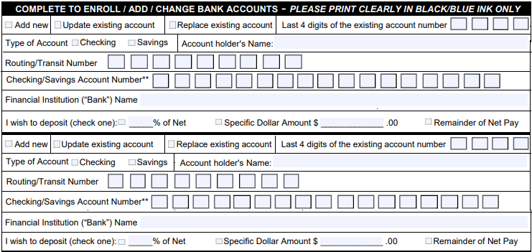

I authorize my employer as noted above, CEOS Corporation dba @TimePay$, Harbor One bank and all financial institution(s) involved in each transaction to deposit my pay automatically to the indicated account(s) and to make adjusting entries including the removal of funds if the employer does not make them available, in which case, I waive any rights I may have to return debit entries to my account and I personally guaranty the return of the funds in question. Deposits are normally available two (2) banking days after payroll is processed. It is my responsibility to verify deposits on a per pay period basis before writing checks against these funds. This Authorization can take up to three (3) pay periods to activate. I understand that neither my employer, CEOS Corporation dba @TimePay$ or Harbor One bank is responsible for bank errors or bank fees. A return for a direct deposit error is $7. Direct Deposit Financial services are provided in accordance with CEOS Corporation dba @TimePay$ Direct Deposit Agreement, Harbor One bank / CEOS Corporation dba @TimePay$ Power of Attorney/Guaranty/Terms and Conditions and the limitations and restrictions of the National Automated Clearing House Association. I may cancel these Direct Deposit(s) at any time.

Employee Signature: _______________________________________________________________ Date: _____________

Account Holder Signature:__________________________________________________________Date: ______________